University of Notre Dame Mass Spectrometry and Proteomics Facility (MSPF): Go-Live Guide
Overview
Support
How do I submit a new Support Ticket?
How do I find and access my existing Support Tickets?
Support-alternative
iLab Helpsite
iLab Status Page
[Institution Name] FAQ’s
Customer Email Templates
Internal Customer Without an Account Email Template:
Internal Customer With a Pre-Created Account Email Template:
External Customer Email Template:
PI Email Template:
Kiosk Instructions Email Template:

Overview

As we move into the final phase of implementation this guide will assist in the transition of iLab go-live in MSPF. This guide will reference support contacts, the iLab Help site and Notre Dame specific information provided for your use as you see fit.

It has been a pleasure to work with you over this implementation period. I hope you have enjoyed your experience. Two weeks post iLab go-live you will receive a survey regarding your experience during this implementation. Your feedback is important to iLab as we are continuously striving to improve our process and maintain a high quality of service.

Support
For all support while using iLab, we recommend the ‘HELP’ link in the upper right hand corner of the screen. Our support team triages all requests and helps route them to the appropriate members of our team - this is typically the quickest way to get help using the system.

How do I submit a new Support Ticket?
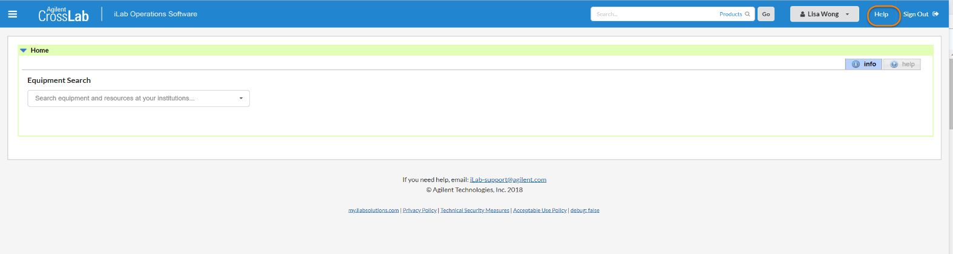

Figure 1. Click HELP to be directed to the help portal.

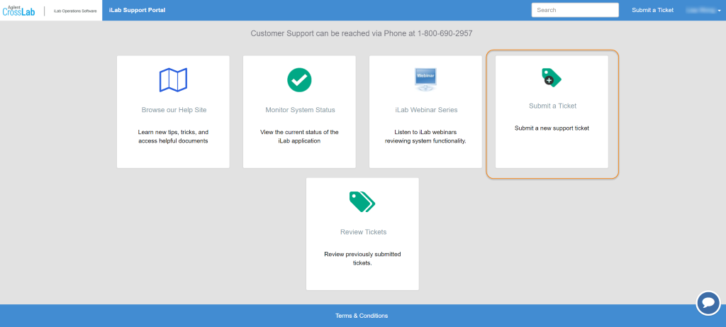
Figure 2. Click on 'Submit a Ticket'

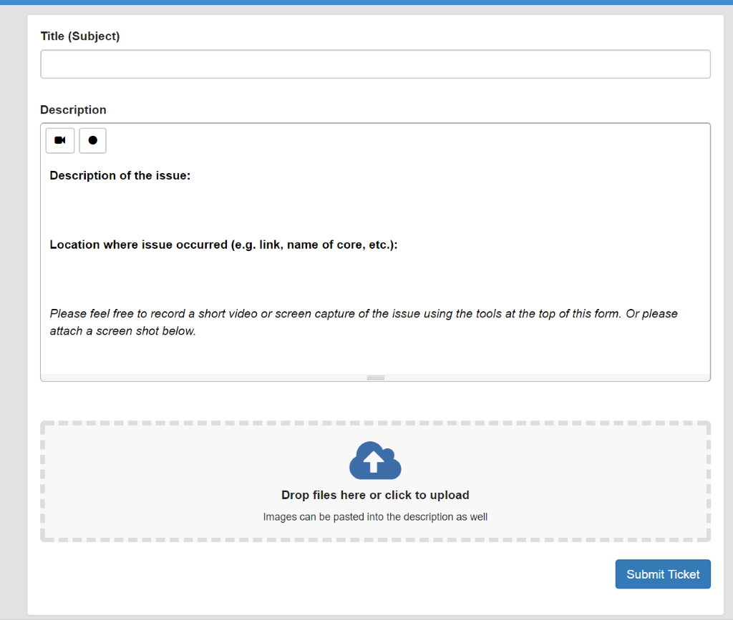
Figure 3. Provide as much detail as possible to help iLab Support Team understand the question or issue.

How do I find and access my existing Support Tickets?

After you have submitted a Support Ticket, click the HELP and you will be directed to the support portal. From here you can click on Review Tickets to see the status of your existing tickets, access the details of a specific ticket to view comments provided by iLab Support Team, and add additional comments to be seen by iLab Support Team.

Support-alternative
If you have problems logging into the system, please feel free to email ilab-support@agilent.com. A team member will either help you directly or route you to the appropriate technical person. Or, you may call the iLab Support Phone.

The toll free iLab Support Phone (US): 1.800.690.2957

The iLab Support Chat: Click the Help link in the upper right-hand corner, select My Tickets, then click the chat icon at the bottom right-hand side of your screen.

Customer support:
If your customers experience a problem with the system, please feel free to encourage them to use the feedback link in the upper right-hand corner. Alternatively, they can email ilab-support@agilent.com. If there is an urgent or critical need, you are welcome to pass along our contact number.

iLab Helpsite and Webinar Information
Sometimes you just need a place to point your customers to for quick iLab instructions! iLab is happy to provide a helpsite dedicated to supplying help documentation for most different roles in the system. The helpsite is always being updated so check back often for new articles.

The iLab helpsite can be located by selecting the HELP link in the upper right-hand corner of the screen. Then select Access to iLab’s help site on the left-hand side.

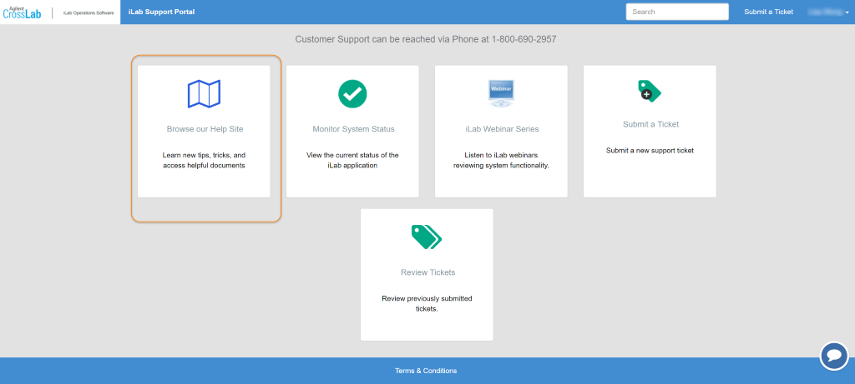.

You can also locate the helpsite here: https://ilab.helpjuice.com/35322-getting-started/299372-welcome-to-ilab-help

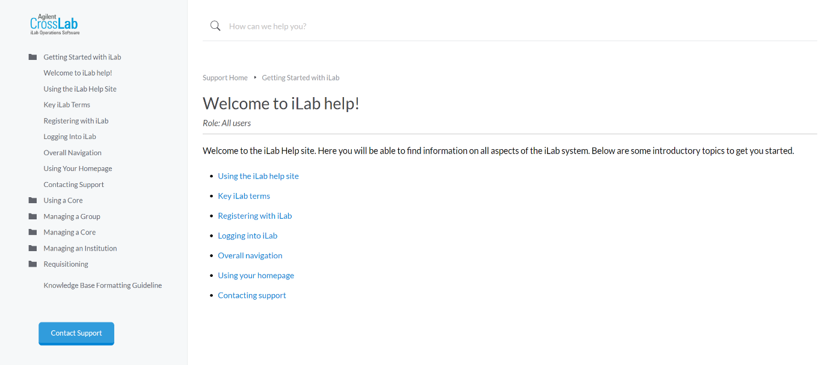

Webinars- Please visit the help site webinars page to view our webinars!

iLab Status Page

Also embedded within the iLab help site is a system status page that can be used to to determine system outages, major functionality bugs being reported. iLab will also use the system status to post notifications for planned downtime.

http://status.ilabsolutions.com/
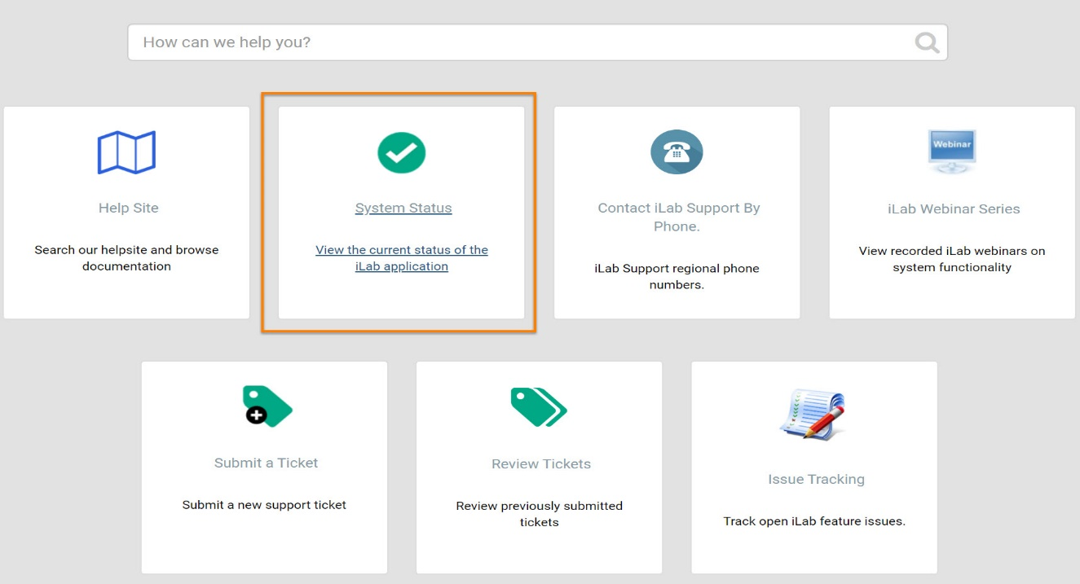

University of Notre Dame FAQ’s

Q: Who should I contact at my institution for financial questions?
A: ndcores@nd.edu

Q: If a user is not assigned funds, where do I send them?
A: The user should first contact their PI and/or lab manager. If they need additional help they can contact ndcores@nd.edu.

Q: Who do I contact for registration questions?
A: ndcores@nd.edu

Customer Email Templates
After we’ve completed your iLab implementation and training, we’ll determine a date to switch your core’s site live so that researchers can see the core in iLab and begin submitting requests and reservations through iLab. We will be sure to remove all test requests in the system prior to notifying users.

You can email the following message to your users when we switch your site live, to notify them about the new system.

Internal Customer Without an Account Email Template:
Dear [CUSTOMER NAME],

Going forward, the Mass Spectrometry and Proteomics Facility (MSPF) at University of Notre Dame is excited to start using an online system to streamline the process of ordering and billing for core service requests. All facility users are invited to use the system, which requires a one-time registration as discussed below. Once you are registered, the system will enable you to place service requests, provide required approvals, and monitor progress.

To register for an iLab account:
To get started, you must register for an account:
- Navigate to the core page: https://nd.ilab.agilent.com/service_center/show_external/5376/mass_spectrometry_proteomics_facility_mspf
- In the upper-right-hand corner of the screen click ‘Sign In,’ and select to sign in using University of Notre Dame credentials
- You will be directed to an authentication page where you will enter your University of Notre Dame
- Once you have entered your credentials, click the ‘Login’ button
- You will be directed to an iLab Registration page where you will select your PI/Lab and verify your contact information.
- Once your registration has been submitted, your PI will receive a notification that you have requested membership to their lab in iLab. They will need to approve your membership and assign any FOP for your use.

To Create an Equipment Reservation for a trained user:
Once you have been accepted into your PI’s lab and assigned FOP, you can schedule equipment time.
- Navigate to the core page: https://nd.ilab.agilent.com/service_center/show_external/5376/mass_spectrometry_proteomics_facility_mspf
- In the upper-right-hand corner of the screen click ‘Sign In,’ and select to sign in using University of Notre Dame credentials
- You will be directed to an authentication page where you will enter your University of Notre Dame credentials
- Once you have entered your credentials, click the ‘Login’ button
- Select the Schedule Equipment tab and click on the ‘View Schedule’ button next to the instrument of interest. Click and drag on the time frame you would like to schedule your reservation for.
- A window will pop up that will allow you to verify your reservations details and provide payment information before saving the reservation.

To Submit a Sample Request:
- Navigate to the core page: https://nd.ilab.agilent.com/service_center/show_external/5376/mass_spectrometry_proteomics_facility_mspf
- In the upper-right-hand corner of the screen click ‘Sign In,’ and select to sign in using University of Notre Dame credentials
- You will be directed to an authentication page where you will enter your University of Notre Dame credentials
- Once you have entered your credentials, click the ‘Login’ button
- Select the Sample Request tab and click on the ‘initiate request’ button next to the Sample Request line.
- You will be asked to complete a form (required fields are indicated by a red star in the sample submission form) before submitting the request to the core.
- Your request will be pending review by the core. The core will review your request and either Agree to the work or they will ask for more information if needed.

Additional help
More detailed instructions can be found on the Help Site by clicking on the “HELP” link in the upper right hand corner or by clicking here. For any questions not addressed in the Help site, click on the “HELP” link in the upper right hand corner and submit a ticket, or email ilab-support@agilent.com.

Sincerely,
The iLab - University of Notre Dame Team

Internal Customer With a Pre-Created Account Email Template:
Dear [CUSTOMER NAME],

Going forward, the Mass Spectrometry and Proteomics Facility (MSPF) at University of Notre Dame is excited to start using an online system to streamline the process of ordering and billing for core service requests. Core staff within the Mass Spectrometry and Proteomics Facility (MSPF) have identified that you request services or equipment use with their core. We have therefore pre-registered you for an iLab account. Once you are registered, the system will enable you to place service requests, provide required approvals, and monitor progress.

Getting Started with iLab:
- Navigate to the core page: https://nd.ilab.agilent.com/service_center/show_external/5376/mass_spectrometry_proteomics_facility_mspf
- In the upper-right-hand corner of the screen click ‘Sign In,’ and select to sign in using University of Notre Dame credentials
- You will be directed to an authentication page where you will enter your University of Notre Dame credentials
- Once you have entered your credentials, click the ‘Login’ button
- On initial login, set your account time zone, click 'update', then log out once to set the change.

To Create an Equipment Reservation for a trained user:
- Navigate to the core page: https://nd.ilab.agilent.com/service_center/show_external/5376/mass_spectrometry_proteomics_facility_mspf
- In the upper-right-hand corner of the screen click ‘Sign In,’ and select to sign in using University of Notre Dame credentials
- You will be directed to an authentication page where you will enter your University of Notre Dame credentials
- Once you have entered your credentials, click the ‘Login’ button
- Select the Schedule Equipment tab and click on the ‘View Schedule’ button next to the instrument of interest. Click and drag on the time frame you would like to schedule your reservation for.
- A window will pop up that will allow you to verify your reservations details and provide payment information before saving the reservation.

To Submit a Sample Request:
- Navigate to the core page: https://nd.ilab.agilent.com/service_center/show_external/5376/mass_spectrometry_proteomics_facility_mspf
- In the upper-right-hand corner of the screen click ‘Sign In,’ and select to sign in using University of Notre Dame credentials
- You will be directed to an authentication page where you will enter your University of Notre Dame credentials
- Once you have entered your credentials, click the ‘Login’ button
- Select the Sample Request tab and click on the ‘initiate request’ button next to the Sample Request line.
- You will be asked to complete a form (required fields are indicated by a red star in the sample submission form) before submitting the request to the core.
- Your request will be pending review by the core. The core will review your request and either Agree to the work or they will ask for more information if needed.

Additional help
More detailed instructions can be found on the Help Site by clicking on the “HELP” link in the upper right hand corner or by clicking here. For any questions not addressed in the Help site, click on the “HELP” link in the upper right hand corner and submit a ticket, or email ilab-support@agilent.com.

Sincerely,
The iLab - University of Notre Dame Team

PI Email Template:
Dear [PI NAME],

Going forward, the Mass Spectrometry and Proteomics Facility (MSPF) at University of Notre Dame is excited to start using, iLab, an online system to streamline the process of ordering and billing for core service requests.

It was indicated that you have researchers who use the core’s services, and we wanted to let you know that you may receive email requests from researchers wishing to join your group. The request email will have specific instructions on how to approve the request. In case you are interested in the process, we have pasted instructions below. If you would prefer to delegate these notifications/approvals to a financial manager, please email ilab-support@agilent.com with your financial manager’s name & email.

Instructions
- Click here to log-in: https://nd.ilab.agilent.com/service_center/show_external/5376/mass_spectrometry_proteomics_facility_mspf
- You will use your University of Notre Dame credentials to log into iLab
- Once logged in, look for the link in the left hand menu that says 'my groups'. Hover-over and select your lab.
- Set the auto-approval amount if you do not wish to approve service requests below a certain dollar amount. To do this, select the 'Members' panel and enter a dollar amount in the 'Auto Pre-Approval' amount and click 'save settings.’
- To approve lab membership requests, select the ‘Membership Requests & FOP’ tab. New membership requests will show at the top of this page. Click “Approve” to accept a member into your lab. Click “Reject” if they are not a member of your lab.
- To assign an FOP to a member of your lab, find the member in the above list where it says, ‘Manage FOP.’ Select the checkbox(es) to the right of their name for the FOP(s) you wish to assign them.

Additional help
More detailed instructions can be found on the Help Site by clicking on the “HELP” link in the upper right hand corner or by clicking here. For any questions not addressed in the Help site, click on the “HELP” link in the upper right hand corner and submit a ticket, or email ilab-support@agilent.com.

Sincerely,
The iLab - University of Notre Dame Team

